

MINNESOTA VOIP INC. Voice & Data Specialists
9217 17th Ave. S. Bloomington, MN 55425 Tel: 612.355.7740 Fax: 952.888.6064

Telephone System Quick Reference Guide
Cisco Model 7940 & 7960 Telephones

HOW TO ANSWER A CALL

Simply LIFT the Handset and you will be connected to the ringing call.
To Answer Via Speakerphone PRESS the SPEAKER Key or PRESS the ANSWER Key on the Display

HOW TO MAKE AN INTERNAL CALL

Lift Handset…. Dial 3 Digit Extension Number ( Note: Extension #s have changed all Extensions are in the 100 range. For example if you were # 650 you are now #150. The old extension will still work for outside callers.

HOW TO MAKE AN EXTERNAL CALL

Lift Handset…..
Dial 10 Digit Telephone Number. (Must Include Area Code for all calls)
For Long Distance calls it is not necessary to dial a 1 before the Phone Number.

HOW TO PLACE A CALL ON HOLD

While in an active call, simply press the HOLD key… (Found on your telephone display)
To return to the call press the Flashing Line key….
Or press the RESUME key (found on your telephone display)

HOW TO ANSWER A SECOND CALL RINGING AT YOUR TELEPHONE

To Answer a Second Call press the Answer key which will appear on the Lower Left corner of your telephone display. This will automatically put the first caller on hold. To return to the first caller,
Press End Call, press Resume key. You can use your up and down arrow button to scroll to call you wish to answer.

Attention: You no longer need to dial a “9” to make a call. All calls are 10 digit. A “1”not needed for long distance.

HOW TO TRANSFER A CALL TO ANOTHER EXTENSION

Answer the Call….. Press the More key (found on telephone display) you the will then press Blnd xfr key
Dial Extension Number ( wait for ring.. hang up)
If you want to announce caller to extension you would choose the Transfer button instead of Blnd xfr. Dial extension wait for party to answer, announce the call press transfer to complete. If party refuses call then press Resume instead of Transfer to be reconnected to caller.

HOW TO SET-UP A 3-WAY CONFERENCE CALL

Place or answer the first call….. press the CONFRN key (found on your telephone display)
Make the second Call (Internal or External )….
Wait for second party to answer…..
press the CONFRN key to join all parties.

HOW TO CALL FORWARD ALL CALLS

To Enable Call Forward Lift Handset and Dial *71
You will be prompted for the Redirection number…
Enter the telephone number you want calls forwarded to followed by the # key.

To cancel Call Forwarding Lift handset and Dial *72

HOW TO ENABLE DO NOT DISTURB

Lift Handset and dial *78.

Note: This will Re-direct all calls to your Voicemail.

To Cancel Do Not Disturb Lift Handset and Dial *79……

COMMONLY USED VOICEMAIL FEATURES

HOW TO SET-UP YOUR PERSONAL VOICEMAIL

Press the messages button on your telephone…..
You will be prompted for your access code. ( all access codes are factory set at 0000 )
You will then be presented with the Main menu of the mailbox…..

PRESS (1) To Hear your Messages
PRESS (2) To Change your Access Code
PRESS (3) To Record Your Name
PRESS (4 ) To Record a Personal Welcome Message
PRESS (5) To Record a Message for another Voicemail Subscriber
PRESS (9) To Select your Mailbox Greeting

HOW TO TRANSFER A CALLER TO VOICEMAIL

Answer the Call….. Press the More key. ( found on telephone display) Then press Blnd Trf followed by
8 plus the extension number then hangup. Ex: 8-150 ( transfers caller to mailbox 150 ) (This prevents the caller from waiting for 4 rings on a normal transfer to get to voicemail)

HOW TO RETRIEVE YOUR MESSAGES

From Your Desk:
Press the messages button……
Enter your Access Code… ( 0000 default ).
Press 1 to listen to Messages

From Outside the Office:
Dial your Personal 10 Digit telephone number…..
When your Personal greeting answers dial *
You will prompted for your Access Code….( 0000 default ).
Enter your Access code
Dial 1 to listen to messages

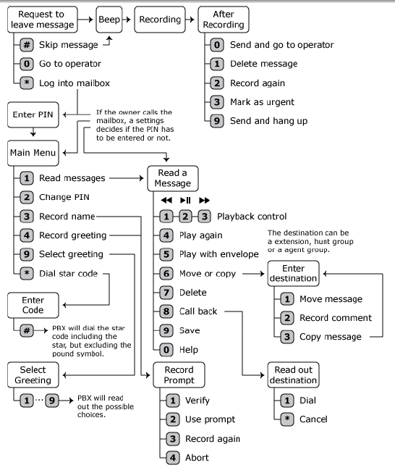
Page 3

